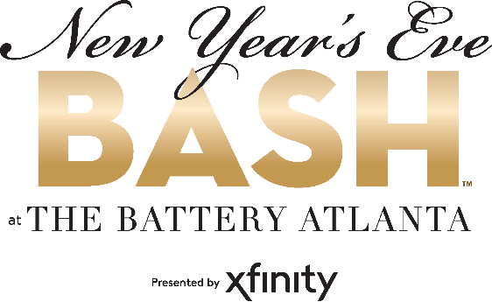
For more information:
Shaye Gulotta
BRAVE Public Relations
404.233.3993
sgulotta@emailbrave.com
FOR IMMEDIATE RELEASE

New Year’s Eve Bash at The Battery Atlanta offers multiple ways to ring in 2021
Cobb County lifestyle destination’s open-air campus offers guests both socially distanced
events and outdoor entertainment

ATLANTA (December 18, 2020) – Say goodbye to 2020 and hello to a brighter 2021 at the annual New Year’s Eve Bash at The Battery Atlanta presented by Xfinity. The community is invited to pop the bubbly at multiple safety-focused celebratory events happening throughout the Southeast’s premier entertainment destination. Select restaurant and bars – including CRÚ Food & Wine Bar, Live! at the Battery Atlanta, Park Bench and El Super Pan, as well as luxury Omni Hotel at The Battery Atlanta – are hosting limited capacity, advanced reservation events.

The 12South Band and DJ Jammin’ John will keep the mood festive in the Plaza starting at 9 p.m., culminating with an aerial firework display over Truist Park at midnight. Parking is free in the public decks (Red, Purple and Green) starting at 8 p.m. on Thursday, Dec. 31 until 1 p.m. on Friday, Jan. 1.

An up-to-date list of restaurant and retailer happenings is available on the website. Details and hours of operation are subject to change. In order to provide a safe celebration for everyone, visitors are asked to observe public safety guidelines as well as the individual guidelines of retailers and restaurants.

New Year’s Eve Events:
An Intimate Affair to Ring in the New Year at CRÚ Food & Wine Bar
Thursday, Dec. 31 from 4 p.m.-midnight
The chef-driven restaurant is dishing out a prix-fixe gala dinner menu complete with four courses ($65). Space is limited so reservations are encouraged. Guests can opt for an intimate dinner or score a late seating for a sophisticated celebration with a complimentary champagne toast at midnight. Learn more here.

NYE Live! 2021 at Live! at the Battery Atlanta
Thursday, Dec. 31 at 8 p.m.
The three-venue sports bar is hosting its annual New Year's Eve celebration with limited capacity in a safe, socially distanced environment. Packages include a masquerade themed event with local entertainment from host Blake Eason, a balloon drop and a midnight champagne toast, featuring a ball drop on the 32-foot LED screen! Learn more here.

New Year's Eve NYE Party at Park Bench
Thursday, Dec. 31 from 8 p.m.-2 a.m.
The well-known live music venue will host two DJs for a late night full of pop, dance and country rock party hits! A limited number of advanced tickets are available and include admission, party favors and a complimentary midnight champagne toast. Select VIP tables with bottle service available. Learn more here.

Countdown to 2021 at Omni Hotel & Resorts at The Battery Atlanta
Thursday, Dec. 31 from 11 p.m.-1 a.m.
Hotel guests can join the luxury hotel for a private, socially distanced countdown to 2021 on the rooftop pool deck. The celebration begins with party favors and a special welcome amenity, in addition to luxurious accommodations with views of The Battery Atlanta from guest rooms. Pool deck festivities include a live DJ, complimentary passed desserts and midnight champagne toast and cash bar. Package availability will be limited to ensure social distancing on the pool deck. Learn more here.

Fiesta de Fin de Año at El Super Pan
Thursday, Dec. 31 from 11 p.m.-1 a.m.
The first 50 guests will be gifted party favors at the door! Attendees can take advantage of $5 Cava all night long. Social distancing required. Learn more here.

Ring in the New Year at Good Game powered by Topgolf
Thursday, Dec. 31 from 10:30 p.m.-1 a.m.
Sip and swing into 2021! Couples can reserve a Swing Suite ($60) or make it a small group outing ($5 for each additional person) for an immersive virtual golf and gaming experience, complete with food and beverage specials. Each space includes a complimentary champagne toast at midnight. Learn more here.

New Year’s Eve & New Year’s Day Brunch at Punch Bowl Social
Thursday, Dec. 31 and Friday, Jan. 1 from 11 a.m.-3 p.m.
Say goodbye to 2020 and hello to 2021 with mimosas, a full brunch menu and non-stop entertainment. Learn more here.
# # #
About The Battery Atlanta
The Battery Atlanta, a 2 million square-foot mixed-use development, located at the intersection of I-75 and I-285, offers an unmatched mix of boutique shopping, market-exclusive entertainment experiences, chef-driven restaurants, the Omni and Aloft Hotels, The Coca-Cola Roxy and 531 residences. The complex includes offices One Ballpark Center, Comcast’s regional headquarters; Two Ballpark Center, home to SPACES; Three Ballpark Center (opening 2021), which will serve as Papa John’s global headquarters and thyssenkrupp’s North American headquarters; and Four Ballpark Center (opening 2020). Powered by Comcast’s all-fiber network and delivering multi-terabit capabilities, The Battery Atlanta has the highest-capacity network serving any mixed-use development in the nation. For more information on The Battery Atlanta please visit batteryatl.com or connect on Facebook, Instagram and Twitter.

